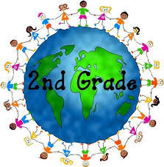
Dear Parents and Guardians,
My name is Aleshia Mund and I am a practicum student at the University of Northern British Columbia. I was born and raised in Abbotsford, B.C. I am a very family orientated person and I enjoy outdoor adventurous activities. I have worked with children for many years and I have spent the last year and a half pursuing my dream of becoming a teacher.
I will be teaching alongside Ms. Chudyk in her classroom until April 8. I look forward to getting to know my Grade 2 class and it is a pleasure to be able to teach your children. Some of the topics I will be covering are double digit addition, forces and motion, and rights and responsibilities.
If you have any questions or concerns, you can always contact me by email and I will respond back as soon as possible. I am open to feedback and suggestions!
Sincerely,
Aleshia Mund (amund@unbc.ca)

Dear Parents and Guardians,
My name is Aleshia Mund and I am a practicum student at the University of Northern British Columbia. I was born and raised in Abbotsford, B.C. I am a very family orientated person and I enjoy outdoor adventurous activities. I have worked with children for many years and I have spent the last year and a half pursuing my dream of becoming a teacher.
I will be teaching alongside Ms. Chudyk in her classroom until April 8. I look forward to getting to know my Grade 2 class and it is a pleasure to be able to teach your children. Some of the topics I will be covering are double digit addition, forces and motion, and rights and responsibilities.
If you have any questions or concerns, you can always contact me by email and I will respond back as soon as possible. I am open to feedback and suggestions!
Sincerely,
Aleshia Mund (amund@unbc.ca)

